Computer Aided Lab A

Name of Student:

Le Hoang Khang

Nguyen Phuong Tu Anh

Mentor:

10.30. – 11.20.2024

Contents

Introduction 3

1 Theoritical part 3

1.1 RC low pass filter 3

1.2 Charging and Discharging of Capacitor 3

1.3 Operational amplifier 3

1.3.1 Operational Amplifier Terminals 3

1.3.2 Inverting operational amplifier 3

1.3.3 Integrating operational amplifier 3

1.3.4 Derivating opeartional ampliefier 3

1.3.5 Adding operational amplifier 3

2 Experiment 3

2.1 Measurement of exp 1 3

2.1.1 Description of experiment 3

2.1.2 Results – diagram, table, graphics 3

2.1.3 3.1.3. Discussion of results 3

2.2 Measurement of exp 1 3

2.2.1 Description of experiment 3

2.2.2 Results – diagram, table, graphics 3

2.2.3 Discussion of results 3

2.3 Measurement of exp 3 3

2.3.1 Description of experiment 3

2.3.2 Results – diagram, table, graphics 3

2.3.3 3.1.3. Discussion of results 4

3 Summary and Outlook 4

4 References 4

# 

# **Introduction**

Acquiring electronic instruments is crucial for engineers to learn how to effectively apply them in their work and research in the future. Four typical electrical instruments commonly used in laboratories include digital oscilloscopes, wave generators, multimeters, and power supplies. The aim of this project is to develop proficiency in operating these instruments in the lab and to gain a deeper understanding of the RC low-pass filter phenomenon in real-life applications. This can be demonstrated by observing signal frequencies and their behavior around the cutoff frequency. Additionally, an amplifier is applied in this experiment to illustrate the circuit's behavior and provide a more comprehensive understanding of its operation.

# **Theoretical part:**

## **RC low pass filter [8]:**

* A low-pass filter (LPF) can be used to remove high frequency components from a signal spectrum.

The circuit consists of a resistor in series with a capacitor. The output voltage is taken across the capacitor as shown:

The low-pass filter circuit can be considered as a voltage divider, the output voltage can be calculated by multiplying the input voltage with the ratio of the capacitor and the resistor in an RC (Resistor-Capacitor) circuit:

(1)

→ The voltage gain formular:

Voltage gain = (2)

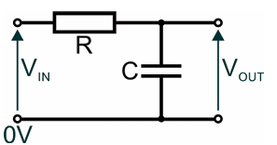

Figure 1: A series RC low-pass filter [8]

* Overview about the RC (Resistor-Capacitor) circuit:

The RC circuits are considered as passive filters which are made from combinations of resistors and capacitors. These circuits can suppress certain frequencies within a frequency spectrum. The cut-off frequency is the frequency at which the value of the capacitor becomes equal to resistor R. This frequency marks the transition between the two extremes:

→ (3)

Substituting Equation (3) to Equation (2), the voltage gain formular at the cut-off frequency:

Voltage gain = = 0.707 (4)

In other words:

## **Charging and Discharging of Capacitor [5]**

The capacitors play a vital as a break in the circuit preventing the flow of a continuous current in DC circuits. However, their behavior seems different in AC circuits. Capacitors can allow a continuous AC current to follow and behaves as a frequency-dependent resistor. When the frequency is low, there is a huge effect on the AC current.

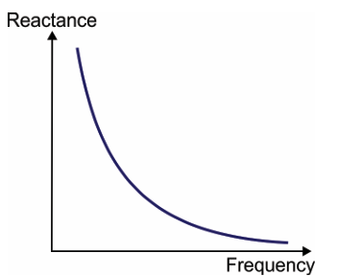

Figure 2: The graph illustrates how capacitive reactance changes as the frequency of the signal changes [8]

The voltage of the capacitor at fully charged condition is . The discharging current of the circuit would be (Ampere) when the capacitor is short-circuited. However, When the input voltage is supplied to the RC low-pass filter circuit, the capacitor begins to store charge at , the current through the circuit is:

(5)

is the capacitor of the RC circuit (F);

*i:* Current through the capacitor (in Amperes, A)

: Rate of change of voltage (V/s)

As per Kirchhoff’s Voltage Law, the relationship between the change of voltage and time is:

(

(6)

R is the resitor of the RC circuit (in Ohm, Ω)

Integrating both sides, the logarithm of output voltage value is:

(7)

Where, A is the constant of integration and, at , the formular of the discharging of Capacitor (8):

(8)

In this experiment, and :

(8) for (9)

With charging of a capacitor [6], the capacitor begins to store charge. If at any time during charging, *I* is the current through the circuit and is the charge on the capacitor, then the sum of both these potentials is equal to

(10)

When :

(11)

From equations (10, 11), the rate of change of this charge is:

(12)

Integrating both sides within proper limits, the formular of the output voltage in time:

(13)

(14)

(15)

For (16)

## **Operational amplifier**

### **Inverting operational amplifier [2]:**

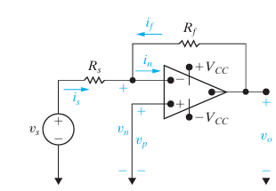

A single node at the inverting terminal of the op amp

Figure 3

Figure 3: An inverting-amplifier circuit [2]

Figure 3 illustrates an inverting-amplifier circuit. In the inverting-amplifier circuit, the circuit connected between the noninverting input terminal and the common node. To obtain an expression for the output voltage, , as a function of the source voltage, . A single node-voltage equation at the inverting terminal of the op amp is given as:

(17)

In this inverting op-amp circuit, the constraint on the input voltages of the op amp is: . And the voltage is set at , because the voltage at . Therefore,

(18)

(19)

Ideally, the equivalent input resistance is infinite, resulting in the current constraint:

(20)

Substituting Equations (17, 18, 19, 20) yields the sought-after result:

(21)

So that the gain of the inverting operational amplifier:

### **Integrating operational amplifier [2]:**

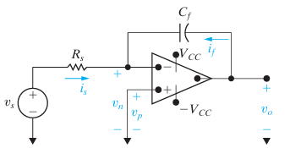

Figure 4

Figure 4: An integrating amplifier [2]

It is assumed that the operational amplifier is ideal:

(22)

(23)

Because ,

(24)

(25)

Hence, from Equations (22, 24, 25, the current flowing through the feedback capacitor is given as:

(26)

Multiplying both sides of Equations (26) by a differential time dt and then integrating from to generates the equation

(27)

Equation (27) states that the output voltage of an integrating amplifier equals the initial value of the voltage on the capacitor plus an inverted, scaled replica of the integral of the input voltage. If there is no energy stored in the capacitor the equation (27) reduces to

(28)

Em nhớ canh dòng nha đều 2 bên + đầu dòng cách vào 1 tab nhoa

### **The operational amplifier Differentiator [7]:**

In the Op-Amp Differentiator circuit, the input is the time-varying function and the virtual ground at the inverting input terminal of the op amp causes to appear in effect across the capacitor . Thus, the current through C will be , and this current flows through the feedback resistor R providing at the op-amp output a voltage

(29)

(30)

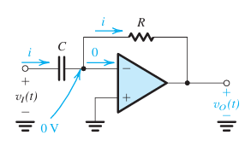

Figure 5

Figure 5: The op-amp differentiator [7]

# **Experiment**

## **Measurement of experiment 1:**

### **Description of experiment 1:**

In this exercise, the fundamental frequency response of an RC low pass filter circuit is analyzed. A low pass filter circuit, consisting of a resistor () and a capacitor (), is constructed and connected to a wave generator and a digital storage oscilloscope (DSO) as shown in the figure below.

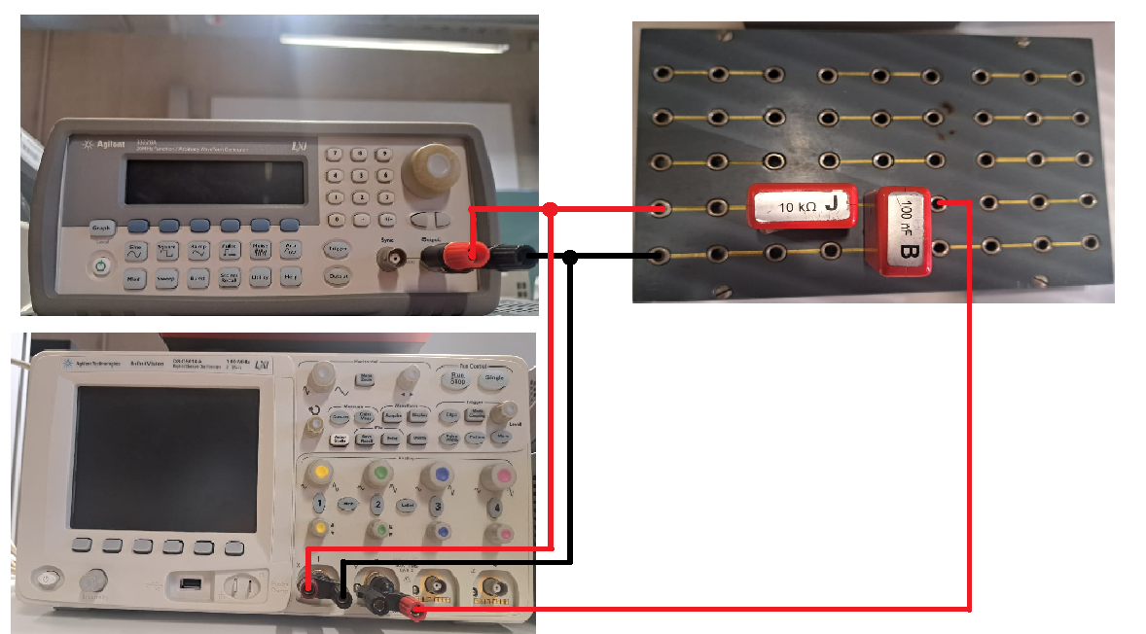

Figure 6: The experiment 1 setup

The wave generator serves as the source, providing varying frequencies and wave types for the exercise, while the oscilloscope captures both the input and output waveforms of the system. Channel 1 of the oscilloscope is connected to both the input of the wave generator and the input of the RC circuit, and Channel 2 is connected to the output of the RC circuit. All grounds for the wave generator, oscilloscope, and RC filter are connected together.

A sine wave input of varying frequency is applied, starting at a low frequency with a peak-to-peak amplitude of 10 V. The frequency is then adjusted to achieve specific amplitude ratios (A) between the input and output, with target ratios of 1, 0.9, 0.8, 0.7, 0.6, 0.5, 0.3, 0.2, and 0.1. The ratio A value is obtained by:

Where is peak to peak voltage of the input wave and is the peak-to-peak voltage of the output wave. Additionally, the phase shift between the input and output signals is measured by DSO tool.

The objective is to observe how the amplitude ratio and phase shift vary as the frequency increases, continuing measurements until the amplitude ratio reaches the specified thresholds. The data is then plotted to illustrate the amplitude ratio and phase shift as functions of frequency. From these plots, the circuit’s cut-off frequency—where the output amplitude falls to approximately 70.7% of the input—is determined and compared with the theoretical value. The phase shift at this cut-off frequency is also recorded.

A sine wave input

### **Results – diagram, table, graphics**

* Calculate the cut of the frequency for the given low pass filter:

Table 1: Frequency Response of an RC Circuit

|  |  |  |  |  |
| --- | --- | --- | --- | --- |
| **Freq. f (Hz)** |  |  | **A** | **Φ[ͦ ]** |
| 1 | 10 | 10 | 1 | 1 ͦ |
| 98 | 9 | 0.9 | 30 ͦ |
| 125 | 8 | 0.8 | 39 ͦ |
| 171 | 7 | 0.7 | 44 ͦ |
| 235 | 6 | 0.6 | 52 ͦ |
| 301 | 5 | 0.5 | 61 ͦ |
| 432 | 4 | 0.4 | 70 ͦ |
| 808 | 2 | 0.2 | 75 ͦ |
| 1718 | 1 | 0.1 | 78 ͦ |

Table 2: Cutoff Frequency and Phase Angle at the Cutoff frequency

|  |  |
| --- | --- |
| **Determined cut off frequency** | 171 Hz |
| **Phase angle φ at cut off frequency** |  |

* The plot demonstrates the relationship between the output voltage and the frequency of output signal:

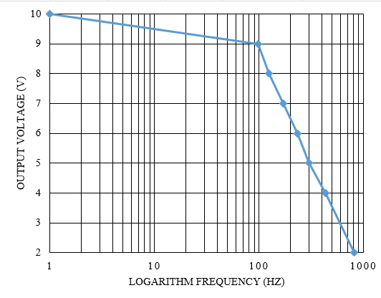

Figure 7: Amplitude ratio and the logarithm frequency

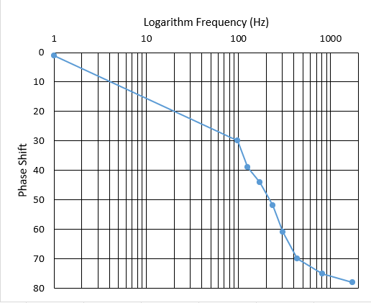

Figure 8: Phase shift and the logarithm frequency

### **Discussion of results**

Based on the Figure 7, the value of output voltage at the cut-off frequency . Besides, based on Figure 8 the Phase shift at the cut-off frequency is approximately equal to . The measured output voltage is slightly larger than the calculated output voltage because three factors. Firstly, the resistor of the wire joint and the connections of the wires are imperfect. Secondly, the deviations of the resistor and capacitor are max value. Thirdly, the error can be caused by the noise from the light source to the oscilloscope.

## **Measurement of experiment 2**

### **Description of experiment 2:**

#### **Exercise 2 part a**

In this lab, the lab aims to analyze the step response of RC circuit. The response of a positive square wave signal input is considered in this experiment. This exercise used the previous set up with the change of the wave generator instead of sine wave, now the square wave is applied. The square wave has an amplitude and a frequency significantly below the circuit’s cut-off frequency (). This ensures that the charging and discharging behavior of the capacitor is clearly observable [2]. Using a digital storage oscilloscope (DSO), the input and output signals are recorded, focusing on the rising and falling edges of the output waveform. The time constant () is determined by measuring the time taken for the output voltage in each case falling edge and rising edge.

For falling edge, the capacitor is in discharging mode. The input voltage equal to zero (, the output of the capacitor is given by:

Where is the initial voltage of the capacitor, is the time constant. For , . So, for the falling edge the time between the initial voltage and its 36,8% is the time constant of the discharging mode the RC circuit.

For the rising edge, the capacitor is in charging mode. The input voltage equal to , where is the supply voltage for a fully charged capacitor. The output voltage is given by:

Where is the initial voltage of the capacitor, is the time constant. For , . So, for the rising edge the time between the supply voltage and its 63,2% is the time constant of the charging mode the RC circuit.

These measured values are compared with the theoretical time constant to validate the circuit's behavior. The output signal is expected to show a smoothed, delayed version of the square wave, illustrating the RC filter’s smoothing effect and providing insights into its transient response characteristics.

#### **Exercise 2-part b**

In Exercise 2 Part b, the step response of the RC low pass filter is re-examined, but this time the input is a positive square wave with a significantly higher frequency compared to the cut-off frequency of the circuit and same amplitude to the previous wave. This setup highlights the behavior of the filter when it is subjected to rapid signal changes. At such high frequencies, the capacitor in the RC circuit does not have sufficient time to fully charge or discharge during each cycle of the square wave.

For further examination of the circuit in Exercise 2 Part b, the positions of the resistor and capacitor are swapped as recommended by the supervisor to gain deeper insights into the behavior of the RC circuit and its interaction with the operational amplifier. In this configuration, the circuit operates as a high-pass filter, emphasizing high-frequency components while attenuating low-frequency signals. In addition to using a high-frequency positive square wave, different waveforms such as sine and triangular waves are also applied to analyze the circuit’s response to various input signal types.

### **Results – diagram, table, graphics and** **discussion of results**

* Calculate the time constant τ from the values of the components as given in the instruction text:

1. Experiment a:

Table 3. The time constant τ on rising edge and falling edge measured at the chosen frequency

|  |  |
| --- | --- |
| Chosen frequency | 25 Hz |
| Measured time constant τ on rising edge | 1.1 ms |
| Measured time constant τ on falling edge | 1.05 ms |

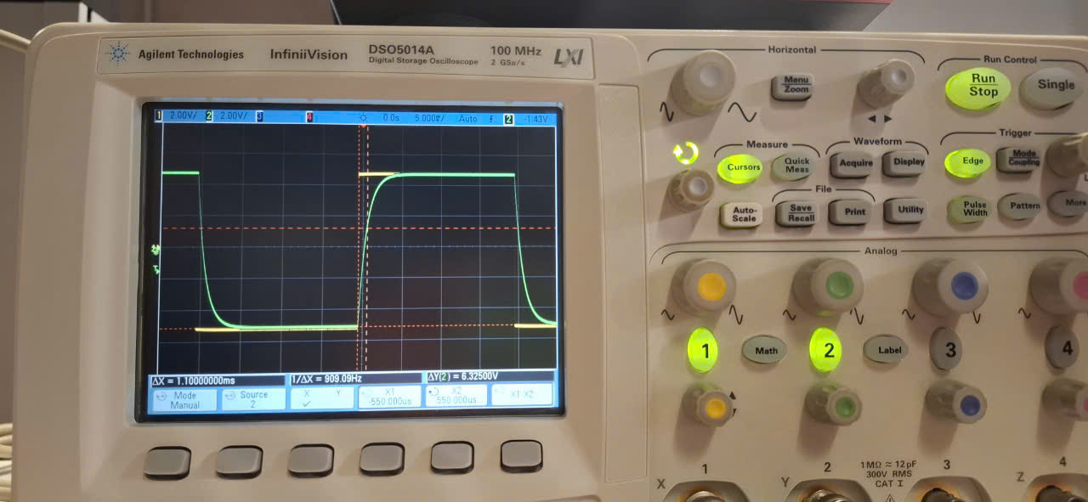

Figure 9: The signals recorded at the frequency

**Discussion:** Based on Table 3, the measured time constant on rising edge and falling edge is approximately equal to each other and equal to the calculated time constant (theory) from the values of the components.

1. Choose a positive square wave with a frequency significantly above the cut off frequency . The signals could be recorded as the figure 10 below.

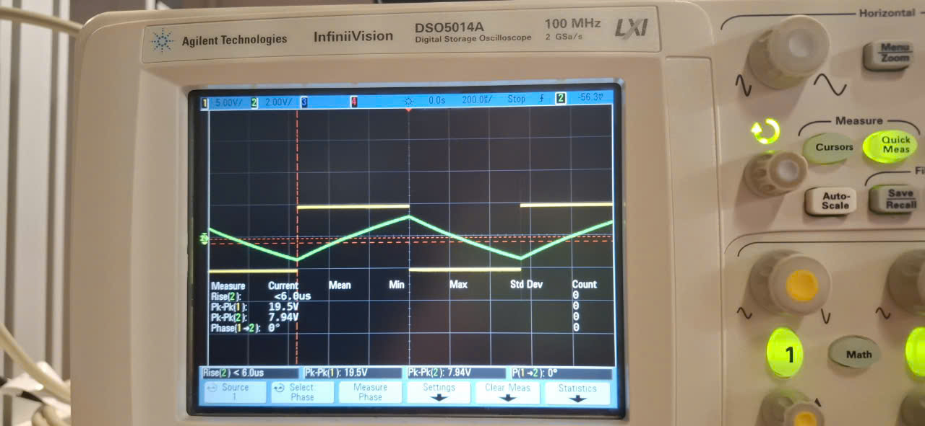

Figure 10: The signals recorded at the frequency f2 = 900 Hz

**Discussion:** From what was observed from the signals at the frequency and , it can be concluded that the behavior of the output signal of Low Pass Filter in both of these cases are identical to each other. However, the time for charging at the frequency is shorter than the time for charging at the frequency . Therefore, the curve of the output signal at as the case in exercise 2a) is not demonstrated clearly in this experiment. Instead of that, the shape of the curve becomes aligned.

**Additional experiment:**  A triangular input wave (RAMP signal) is generated from the wave generator and connected to the circuit. As the result, the output signal is the signals having parabolic shape as the Figure 11 below.

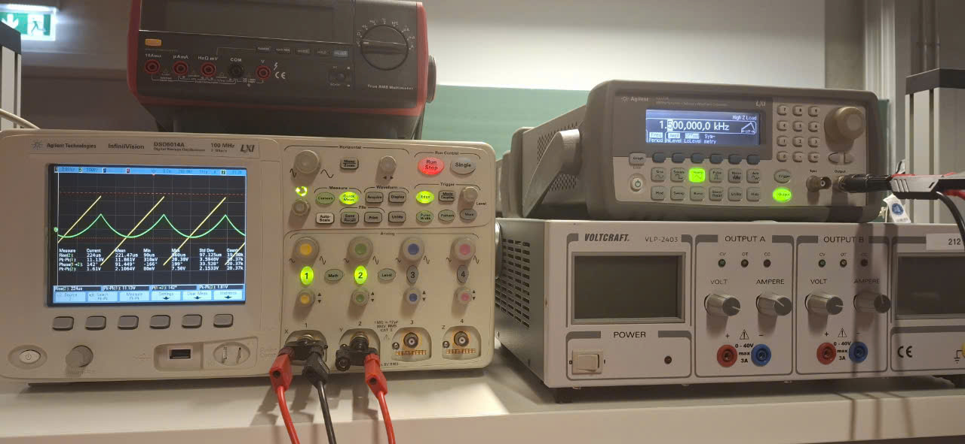

Figure 11: The output signal created from the RAMP input signal

With RAMP signal, the charging speed of capacitor is increasing gradually, which create the parabolic shape in the figure 11 above.

As what can be seen in the figure 11, the yellow lines are the input signal . The green lines are the output signals which are integrated from the input signals as the below formular:

Based on this formular, it can be explained why the output signal have the parabolic shape. At the high frequency, the low pass filter acts as an integrated amplifier with the square signal to the triangular signal.

## **Measurement of experiment 3**

### **Description of experiment**

#### **Exercise 3 part a**

In the exercise 3-part a, the lab aims to analyzing the frequency response of an inverting operational amplifier circuit. Initially, an amplifier circuit is set up as Figure 12a, 12b, with resistor .

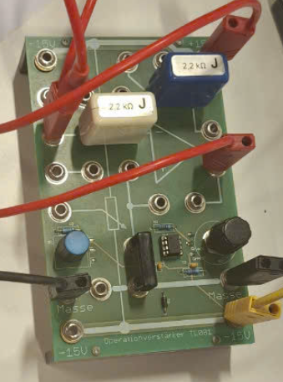 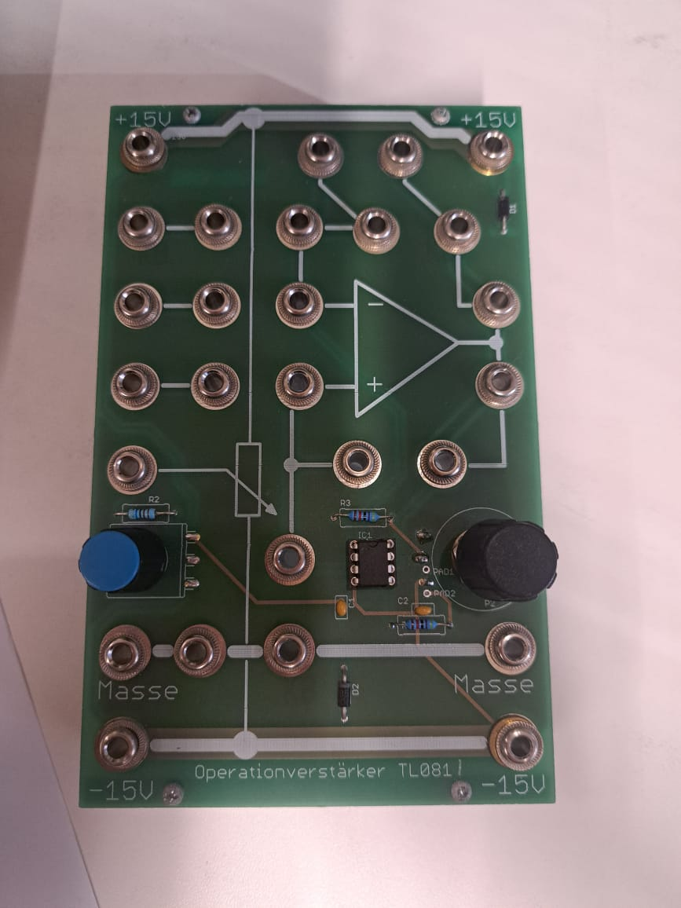

Figure 12: a) the lab set up for the amplifier circuit b) initial amplifier circuit

To creates a dual power supply with both positive and negative output voltages, a programmable power supply (PG) is used. This setup involves connecting the negative terminal of Channel 1 to the positive terminal of Channel 2, effectively creating a midpoint that serves as the reference or "ground" (masse). This configuration provides a power source with a range of , or other voltage levels depending on the PG settings. The positive terminal of Channel 1 is connected to the input of the amplifier circuit, supplying the positive voltage. Similarly, the negative terminal of Channel 2 is connected to the input of the amplifier circuit, supplying the negative voltage. The midpoint connection between the two channels is linked to the "masse" port of the amplifier circuit to establish a common ground. The set up for the lab is shown in figure 13 bellow.

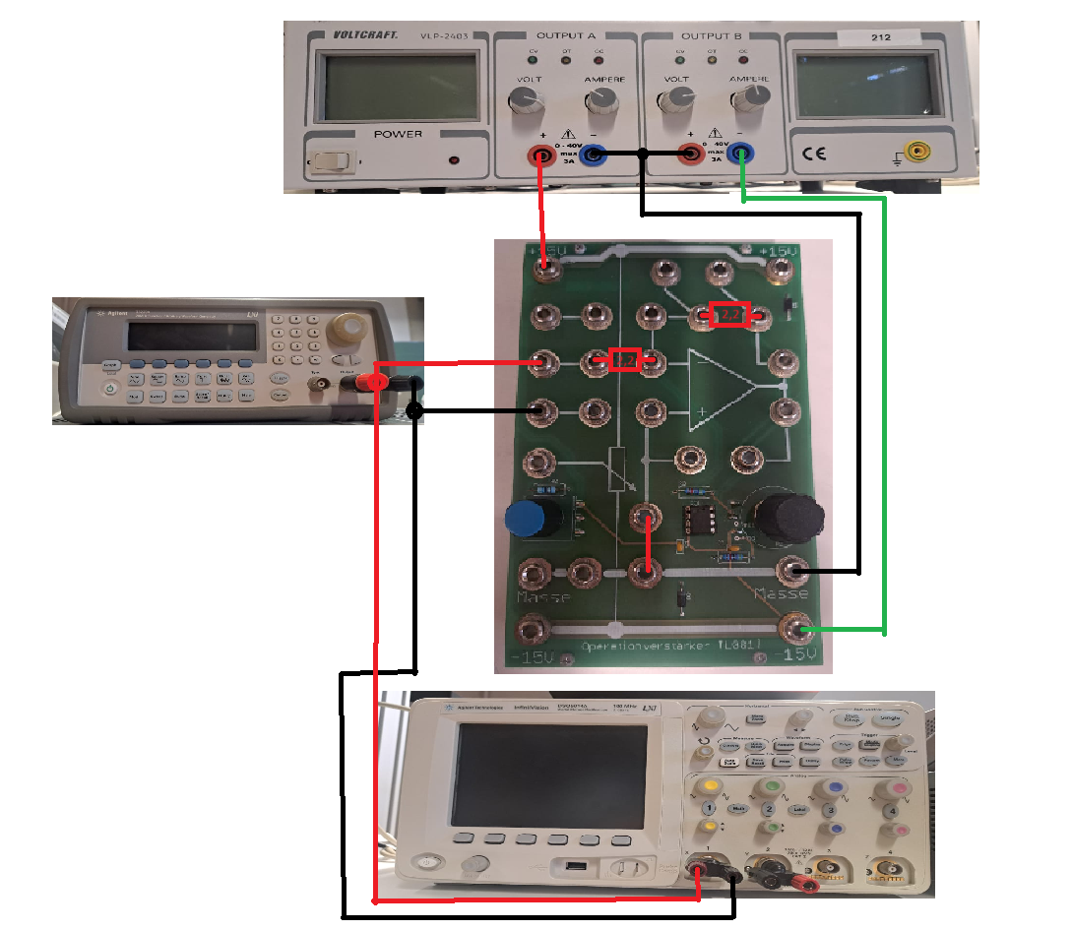

Figure 13: The lab set up

The measurement process mirrors that of Exercise 1. The wave generator provides varying frequencies and waveforms, while the oscilloscope captures input and output waveforms. Channel 1 connects to the wave generator and amplifier circuit input, and Channel 2 connects to the amplifier circuit output, with all grounds linked. A sine wave with a peak-to-peak amplitude of is applied at varying frequencies. The amplitude ratio is measured for specific values (1, 0.9, 0.8, etc.), along with the phase shift. Measurements continue until the amplitude ratio reaches the target thresholds. Results are plotted to illustrate amplitude ratio and phase shift versus frequency, determining the cut-off frequency (where amplitude is of the input) and its corresponding phase shift, which are compared to theoretical predictions.

#### **Exercise 3 part b**

Repeating Exercise 3 Part a with a modification, the second resistor is replaced with instead of the original value. This change increases the gain of the inverting operational amplifier, which is determined by the ratio gain .

### **Results – diagram, table, graphics**

Table 4: The frequency response of the op-amp circuit with the value of resistors )

|  |  |  |  |
| --- | --- | --- | --- |
| **Frequency f** |  |  | **A** |
| 10 Hz | 10 | 10 | 1 |
| 851 kHz | 9 | 0.9 |
| 951.570 kHz | 8 | 0.8 |
| 1.151570 MHz | 7 | 0.7 |
| 1.391570 MHz | 6 | 0.6 |
| 2.291570 MHz | 4 | 0.4 |
| 4.311570 MHz | 2 | 0.2 |

|  |  |
| --- | --- |
| Determined cut off frequency | 1.15157 MHz |

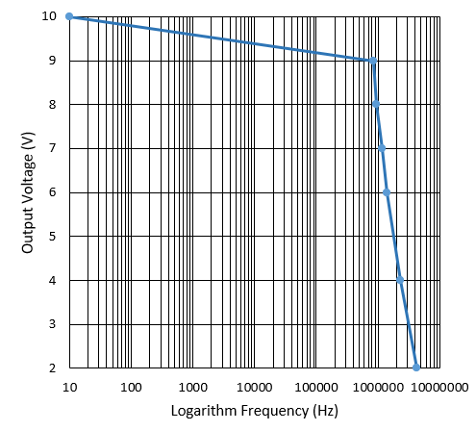

Figure 14: Output voltage and Logarithm Frequency with

the cut off frequency

Table 5: The frequency response of the op-amp circuit with the value of resistors )

|  |  |  |  |
| --- | --- | --- | --- |
| **Frequency f** |  |  | **A** |
| 1 Hz | 1 | 10 | 10 |
| 190.367 kHz | 9 | 9 |
| 290.367 kHz | 8 | 8 |
| 390.367 kHz | 7 | 7 |
| 510.367 kHz | 6 | 6 |
| 860.367 kHz | 4 | 4 |
| 1.720 MHz | 2 | 2 |
| Determined cut off frequency | | 390.367 kHz | |

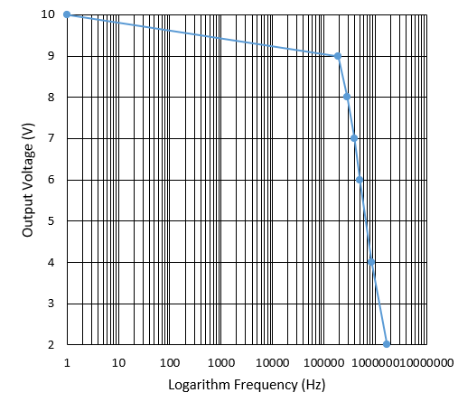

Figure 15: Output voltage and Logarithm Frequency with

the cut off frequency

### **Discussion of results**

Based on the data in Table 4, at the cut-off frequency the output voltage starts decreasing significantly. With the gain values from 0.2 to 1, the op-amp can endure the frequency of input signal 1 MHz. When kHz, which is approximate the theoretical value gain which is equal to 1, while , the gain decreases significantly because the rate of change in the frequency of signal is too fast. Therefore, the electrical instruments could not adapt to the change of the frequency of signal.

Based on Table 5, at the cut-off frequency , the output voltage starts decreasing significantly. The circuit which has the gain value higher than the circuit in the experiment 3a) 10 times from 2 to 10 will work efficiently the frequency around . In this case, the behavior of frequency response is similar to the behavior frequency in the case 1. However, the gain of the op-amp in case 2 is higher than the gain in case 1, so that the cut-off frequency is lower than the one in case 1 and the drop of gain occurs at the smaller frequency .

To sum up, the op-amp which has the higher gain will have the smaller cut off frequency.

# **Summary and Outlook**

In the first and the second experiment, the behavior of Low Pass filter circuit can be observed through connecting wave generator to the circuit to generate the input signal (sine wave and square wave). More than that, by using the oscilloscope, the output voltage signal can be measured and observed. Therefore, the relationship between the frequency of input signal and the output voltage signal can be demonstrated. The wave signal observation illustrates the principle of Low Pass filter circuit. Similarly, in the experiment 3 the behavior of the inverting op-amp circuit is identical to the behavior of Low Pass Filter. However, the cut off frequency is much larger than the cut off frequency of Low Pass Filter. It can be concluded that although in the theory the ideal op-amp have cut off frequency, in reality when the frequency of input signal is too high, the op-amp cannot process output signal.

# **References**

1. Storr, W. (2024) *Low pass filter - passive RC filter tutorial*, *Basic Electronics Tutorials*. Available at: https://www.electronics-tutorials.ws/filter/filter_2.html (Accessed: 12 November 2024).
2. Nilsson, J.W. and Riedel, S.A. (2015) Electric Circuits. Boston: Pearson.
3. Storr, W. (2024a) Introduction to capacitors, capacitance and charge, Basic Electronics Tutorials. Available at: https://www.electronics-tutorials.ws/capacitor/cap_1.html (Accessed: 12 November 2024).
4. Storr, W. (2024c) Operational amplifier basics - op-amp tutorial, Basic Electronics Tutorials. Available at: https://www.electronics-tutorials.ws/opamp/opamp_1.html (Accessed: 12 November 2024).
5. Learn Electrical & Electronics Engineering (for free) (2024) Electrical4U. Available at: https://www.electrical4u.com/ (Accessed: 12 November 2024).
6. *Personalised learning* (no date) *BYJU’S*. Available at: https://byjus.com/ (Accessed: 12 November 2024).
7. Sedra, A.S. *et al.* (2021) *Microelectronic circuits*. New York: Oxford University Press.
8. WJEC. (2018). *GCE A Level Electronics – Chapter 4: AC Circuits and Passive Filters*